Colorado’s Near-Infrared Camera (a.k.a. NIC-FPS)
Commissioning on the ARC 3.5M Telescope

Fred Heartyª, Stephane Belandª, James Greenª, Nathaniel Cunninghamª,
John Barentine^{b}, Meredith Drosbackª, Robert Valentineª, Anton Bondarenkoª, Carl Schmidtª,
Joshua Walawenderª, Cynthia Froningª, Jon Morse^{c}, Patrick Hartigan^{d}
ªUniversity of Colorado, Center for Astrophysics and Space Astronomy, 593 UCB,
1255 38th St., Boulder CO 80309-0593
^{b}New Mexico State University, Apache Point Observatory
2001 Apache Point Road, P.O. Box 59, Sunspot NM 88349-0059
^{c}Arizona State University, Department of Physics and Astronomy
PO Box 871504, Tempe AZ 85287-1504
^{d}Rice University, Department of Physics and Astronomy
PO Box 1892, Houston TX, 77005-1892

ABSTRACT

A second generation near-infrared instrument was built by the University of Colorado for the ARC 3.5 meter telescope and is being commissioned at the Apache Point Observatory. An initial engineering run, first light, commissioning observations, and initial facility science operations have been accomplished in the last year. Instrument imaging performance was good to excellent from first light and consortium observers began to employ the instrument on a shared-risk basis immediately after commissioning operations. Instrument optical and mechanical performance during this testing and operations phase are discussed. Detector system (Rockwell Hawaii-1RG 1024x1024 HgCdTe focal plane array with Leach controller) characteristics during these early operations are detailed along with ongoing efforts for system optimization. High resolution (R~10,000) spectroscopy is planned employing a Queensgate (now IC Optical) cryogenic Fabry-Perot etalon, though mechanical difficulties with the etalon precluded a system performance demonstration. The Consortium has decided that the instrument will retain the name NIC-FPS (Near Infrared Camera and Fabry-Perot Spectrometer) after commissioning.

1. INTRODUCTION

1.1 Instrument Description
The University of Colorado has built and is commissioning a second generation near-infrared (NIR) instrument for the Astrophysics Research Consortium (ARC) 3.5 meter telescope at Apache Point Observatory in Sunspot, New Mexico. Named Near-Infrared Camera and Fabry-Perot Spectrometer (NIC-FPS), the instrument is currently at the observatory and is being employed for science operations. Based on solid early performance, it has already replaced the aging GRIM II which provided the community’s only NIR imaging and spectroscopy as detailed in Hereld et al. (1990). Optimizing the detector system and adding new operations software are ongoing efforts. Emergent maintenance and rework requirements which were identified during commissioning are planned for this summer’s shutdown.

The instrument is designed to provide low noise imaging and full field spectroscopy for galactic and extragalactic science programs. Current operations are solely employing the imaging mode as the Fabry-Perot etalon has been removed for vendor repair and realignment. Notable science data have already been obtained in the imaging mode for a diverse set of targets, including solar system objects, galactic star formation regions, and extragalactic objects at high redshift and with considerable dust obscuration.

A brief description of the optical design is provided for completeness; a more detailed account can be found in Vincent et al. (2003, hereafter Paper 1) and Hearty et al. (2004, hereafter Paper 2). The ARC telescope is a 3.5 m, f/10.35 modified Richey-Cretien. A set of interchangeable instruments are available for use at the Nasmyth 2 port by the ARC community. The Nasmyth 1 port is dedicated to an echelle spectrograph. NIC-FPS will be mounted at the Nasmyth 2 port when in service.

NIC-FPS optics are designed to provide (at 2 μm) 2 pixel sampling under good seeing conditions of ~0.5” full width at half maximum (FWHM), and 3 pixel sampling at median seeing conditions of ~0.9”. These requirements dictated a f/3.99 camera with a 0.27” pixel⁻¹ scale. The effective focal length is 13,590 mm. NIC-FPS is the first ground-based instrument to employ the Rockwell Hawaii-1RG 1024x1024 HgCdTe detector with 18 μm pixels (1016x1016 pixels are active). The field of view is 4.58’ edge-to-edge and 6.42’ corner-to-corner.

The collimator is a three-element optical assembly built by Janos Technology, Inc. The lenses are, in order, optical grade fused silica, CaF₂, and ZnSe contained in a single aluminum housing. This distance allows the f/10.35 beam to expand to the pupil size of 40 mm. No corrector lens is required in front of the telescope focus. The pupil is located 310 mm behind the collimator. This space allows ample room for three (upgradable to four) filter wheels with additional space for future optical equipment. Angular magnification at the pupil is the ratio of the primary diameter to the pupil diameter or 85x.

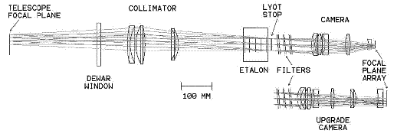
Figure 1. Optical layout of NIC-FPS. Dewar (entrance) window is the boundary of the vacuum volume. Other components are operated near LN2 temperature. Etalon is shown in the full-field spectroscopy position and is retracted for the imaging mode. Note that the as-built system swaps the locations of the etalon and filters on the sides of the Lyot stop due to physical space limitations on the optical bench. The upgrade camera is a potential future enhancement to a 2k x 2k detector.

The 0.39:1 camera, also by Janos, has five elements in a single housing. These are distributed in a triplet (ZnSe, CaF₂, fused silica) followed by a singlet (CaF₂₎ and a field flattener (fused silica). The optical design was done in Code V and optimized in Zemax.
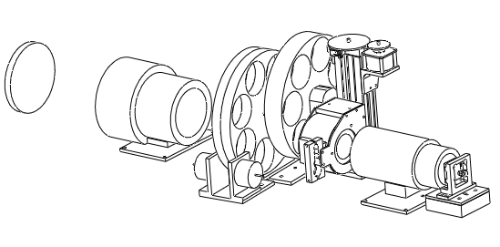
Entrance Window
Collimator
Etalon Mover
Camera
Filter Wheels
Focal Plane Array Mount
Etalon
Figure 2. The physical layout of the optical components shows the collimator (3 elements) and camera (5 elements) housings, the double and single filter wheels, and the etalon in the optical path.
Image quality of the baseline design is close to the diffraction limit. RMS spot diameters (including the 3.5-m telescope) are maintained below the pixel size at all wavelengths and positions on the detector. No refocusing is necessary over the operational wavelength range. To simplify manufacturing and reduce cost, all surfaces on both the collimator and camera lenses are spherical and were matched to existing (Janos) test plates. Additionally, assemblies were thermally cycled to LN2 temperatures by the vendor before delivery.
The filter wheels, one single and one double, are based on an Ohio State University Imaging Sciences Laboratory design. Each wheel is positioned by a cryogenic stepper motor through a pinion gear in contact with a spur gear located around the wheel’s circumference. Limit switches continuously monitor the rotational position of each wheel and the final position when the selected filter is aligned to the optical axis. The wheels have seven slots each with one left empty for a total of eighteen filter slots. Currently, the space is allocated to broadband filters J, H, and K_{s} (Mauna Kea Filter Set) that were purchased from Barr Associates as part of the Gemini filter consortium and a Z band filter. Central wavelengths are 1.250, 1.635, 2.125, and 1.000 μm respectively. A set of twelve narrow band filters, one blocker, and one as yet unallocated slot complete the inventory. A low resolution grism is being installed to fill the last slot.

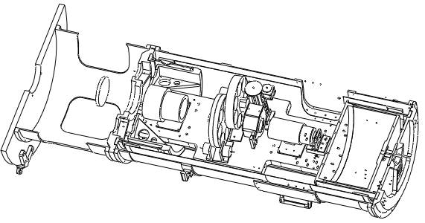
Cold stand-off assembly
Front housing
Vacuum bulkhead
Mounting plate
Optical bench assembly
Figure 3. Cut-away view of the NIC-FPS instrument
Access doors
Liquid nitrogen tank
Dewar housing

A brief description of the mechanical design is also provided for completeness; a more detailed account of the instrument’s as-built opto-mechanical system can be found in Paper 2. The optical components are mounted on a fully cantilevered structure at the telescope’s Nasymth 2 port. Beginning at the telescope rotator face, the structure consists of a mounting plate, front housing, vacuum bulkhead, cold stand-off assembly, and optical bench assembly (see Figure 3). The entire structure is designed for rigid support of the optical components at all angles as the instrument is required to rotate about the optical axis a full 360 degrees in either direction (since the ARC3.5 is an altitude/azimuth system needing an image de-rotator). The Dewar housing provides mechanical support to the liquid nitrogen (LN2) tank, independent of the optical bench. The LN2 tank is thermally attached to the optical bench by a set of four thermal straps, manufactured in house. Access to the thermal straps after Dewar housing and LN2 tank installation is provided by a pair of access doors. The doors are o-ring sealed and bolted to the Dewar Housing. LN2 tank filling is accomplished via an on-axis fill line – the tank is filled to the axis (half of the tank volume) with 18.1 liters of LN2 to provide approximately 36 hours of hold time. The tank operates at atmospheric pressure and is vented into the front housing to provide a dry atmosphere that prevents entrance window fogging.

1.2 Scope of Report
This third and final report documents instrument performance during commissioning and initial science operations. The previous report provided details of the as-built opto-mechanical system of NIC-FPS and served as NIC-FPS Paper 2. Paper 1 provided optical design details and instrument specifications. Section 2 below describes the instrument performance during initial testing and science operations. Section 3 provides a brief description of remaining work. Section 4 summarizes and concludes the report.

2. INSTRUMENT PERFORMANCE

2.1 Engineering Run – September 20, 2004 to October 4, 2004
The NIC-FPS engineering run, originally scheduled for August 2004, was planned as a first trip to the mountain to test those features of the instrument which could only or best be demonstrated on the telescope. The main mechanical issues were rotational balance, alignment, and functional performance of the overall system. Optically, the plan was to test for optical alignment and performance of the Janos-built collimator and camera. The instrument was delivered essentially complete with the notable exceptions of the engineering-grade instead of the science-grade detector, a partial filter set, and the absence of the Fabry-Perot etalon. Full readiness for the commissioning phase (or the need for a second engineering run) was to be determined by first engineering run performance. The bottom line was that the instrument performed exceptionally well for its first time on the telescope and a second engineering run was not required. Figure 4 below shows the instrument being unloaded at Apache Point on September 21st and being mounted on the rotator the same day. Mechanical balance was achieved within the first hour on the rotator; only slight adjustments of the kinematic bars were needed to balance the instrument.

Worth noting is the fact that the bulk of the instrument design, integration, and testing was the work of a team of undergraduate and graduate students at the University of Colorado.

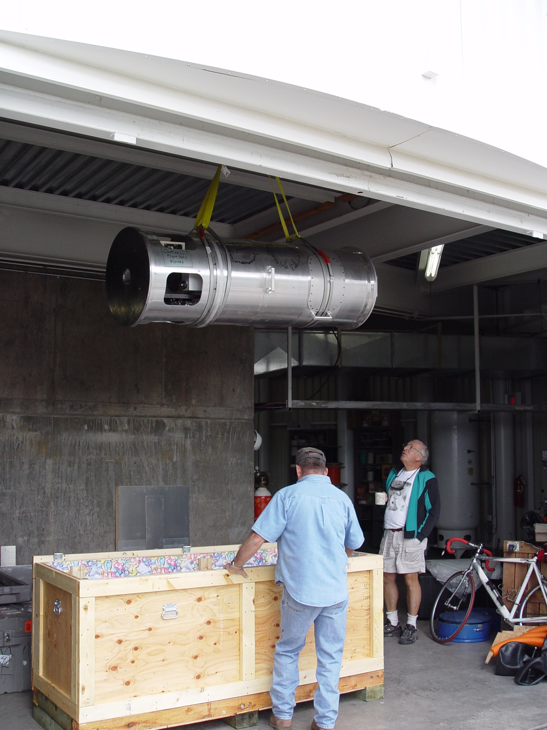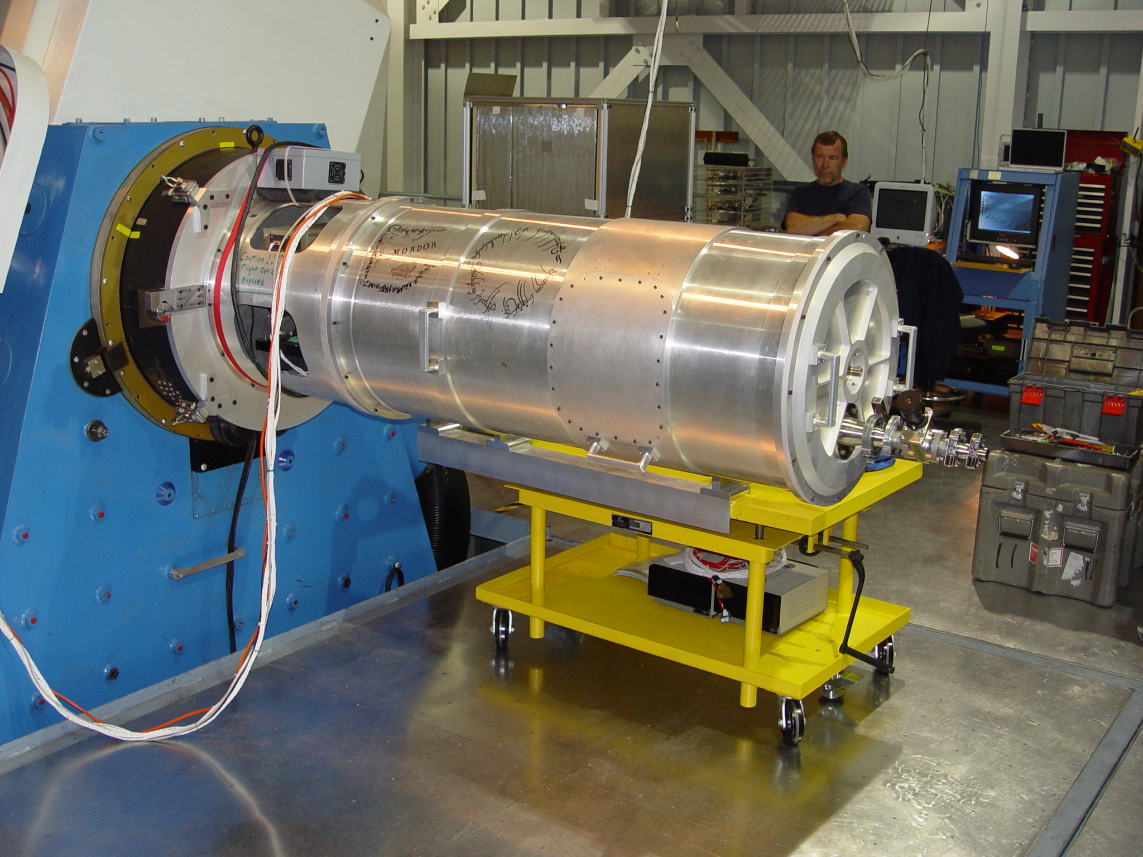
Figure 4. At left, instrument is unloaded at Apache Point Observatory and raised to the observing deck of the 3.5M telescope. Above, NIC-FPS is shown mounted on Nasmyth 2 rotator face for the first series of mechanical tests. Yellow cart is used to mount, un-mount, and store the instrument. Much of the design, integration, and testing of NIC-FPS was performed by students, whose signatures were evident as art work on the instrument and a colorful shipping crate.

The instrument was integrated into the observatory systems, pumped to establish vacuum, and cooled over the next two days. First light was obtained at twilight on the second day, September 23rd. The Observatory Director provided the twilight time based upon instrument preparations running ahead of schedule. During the brief (20 minute) window of opportunity which included first light, a first focus check was also accomplished that resulted in a symmetrical, 3 pixel full width at half maximum (FWHM) point spread function (PSF). This 3 pixel spot corresponds to 0.8 arcsececond seeing, typical for the APO site. The focus point was also near (+150 microns) the midpoint of the secondary travel as desired. Figure 5 below shows the encouraging results of these first tests. The source of the noise that is evident in both profiles at lower right and in some Figure 6 PSFs was eventually tracked down and eliminated.

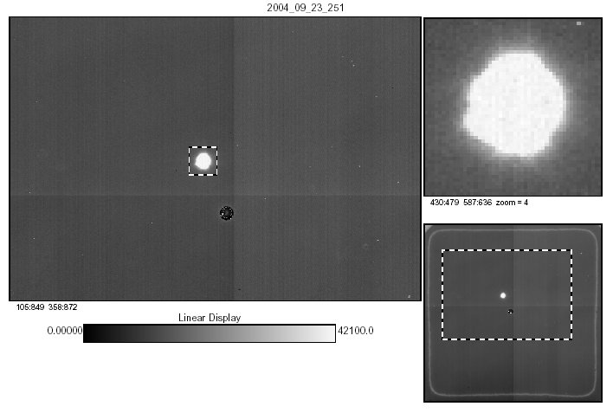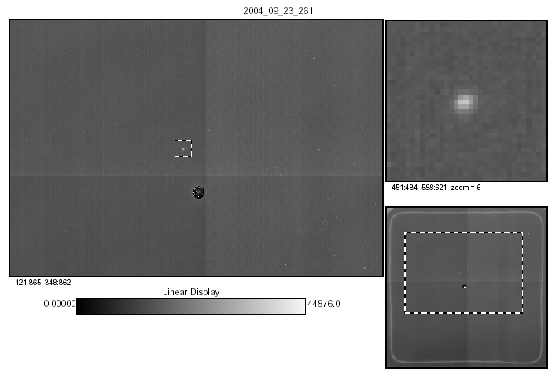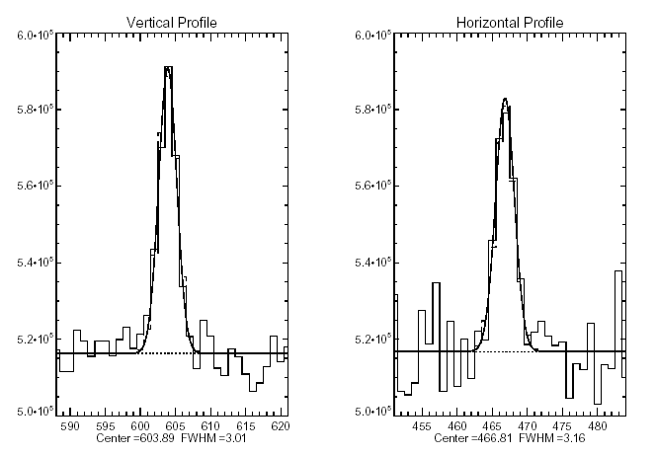
Figure 5. Below is first light on the instrument at the ARC3.5 M telescope. Vega was imaged near the center of the detector field. At right, a 10.7 magnitude star was selected for a first focus sweep. Approximately 20 minutes into twilight, the star was focused into a 3 pixel FWHM, symmetrical point spread function (lower right) which was near the theoretical limit of atmospheric distortion (seeing).

Three half nights of about 6 hours each were scheduled for the engineering run tests on the telescope. Rain precluded observations during all but 1.5 hours of this scheduled time. On September 25th, an “instrument block” was run on NIC-FPS. This test defines the rotational center of the detector in physical telescope coordinates and establishes the plate scale of the pixels. It is also an excellent test of optical bench deflection and detector/optics alignment and flatness of focus. Figure 6 shows the rotational alignment and full field focus demonstrated during the first instrument block procedure. Alignment varied by 0.47 pixels from a perfect circle which corresponds to 9 microns on the detector face. The optic bench was shown to be slightly more rigid in the 90/270 degree rotational positions as predicted by mechanical models. Focus was shown to be essentially flat across the field as depicted by five comparable sets of PSFs for same star at various pointing offsets. The star’s five positions are superimposed onto a single image.

Since rain precluded all but 1.5 hours of planned on-sky time, the Observatory Director issued an engineering preemption for the next available clear night(s) so that the minimum required engineering run testing could be accomplished. On the evening of September 30th, the first clearing was experienced and the required tests were accomplished in 5.5 hours.
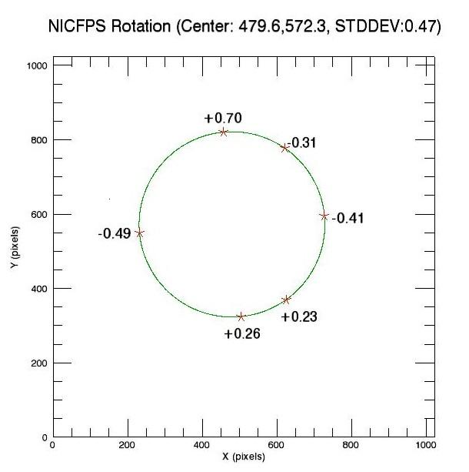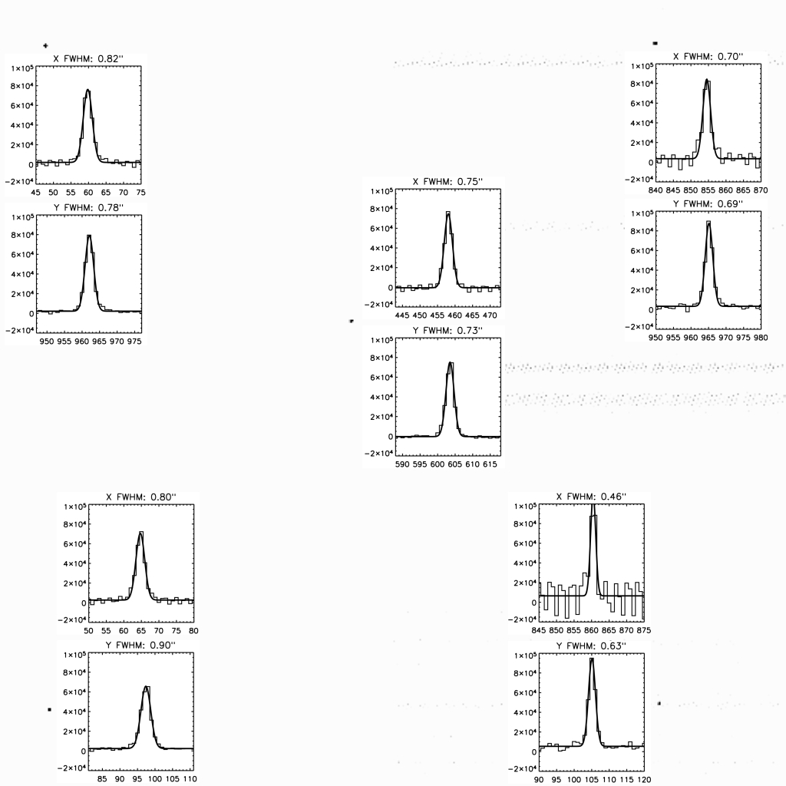
Figure 6. Above shows rotational alignment (left) and full field focus demonstrated during the first instrument block procedure. Alignment varied by 0.47 pixels from a perfect circle which corresponds to 9 microns on the detector face. The optic bench was shown to be slightly more rigid in the 90/270 degree rotational positions as predicted. Focus was flat across the field.

During this time, star fields were imaged to verify flatness of focus across the field, field distortion, Lyot stop alignment, and sky saturation times for the various broadband filters. Additionally, several science images were obtained with

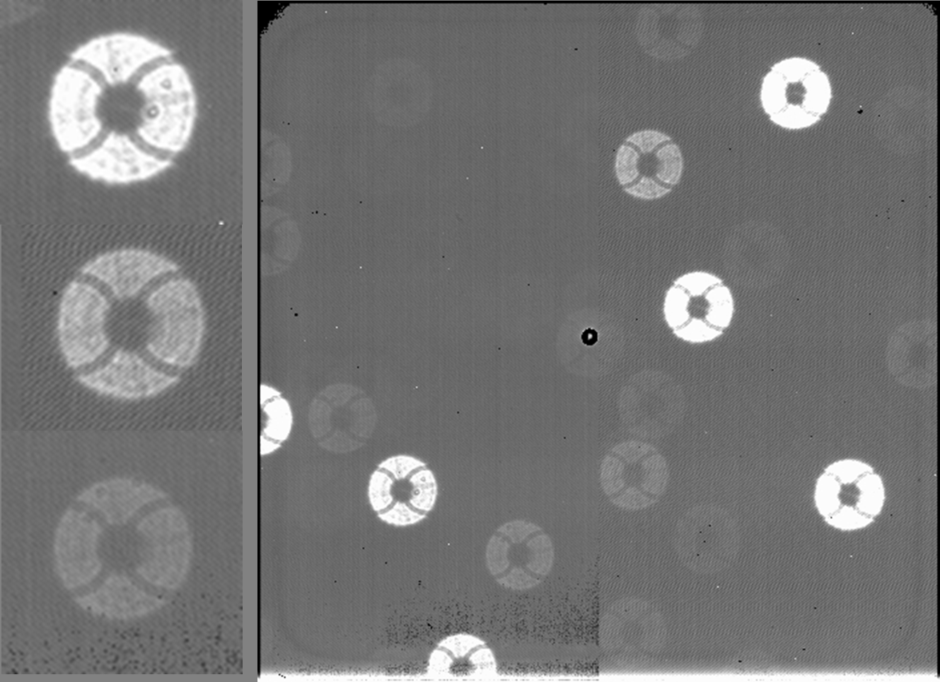
Figure 7. To the left is part of the M29 Open Cluster star field, defocused to show the curved arms of the Lyot stop. The three magnified images also show the alignment of the secondary support structure as a faint cross pattern. Lyot stop alignment was determined to be nearly aligned with a slight offset to the left in the image frame. This offset was mostly due to placing the filters ahead of the Lyot stop.

narrow band filters to check the instrument performance on extended, diffuse objects. Figure 7 shows the Lyot stop
alignment demonstration which was accomplished by defocusing the secondary to both extremes. The curved arms and central obscuration of the Lyot stop are seen. (Curved arms were used to avoid diffraction spikes from the Lyot stop.) A slight misalignment to the left in the image frame was found and determined to be due, in large part, to the filters which were placed before the stop. This change was required because of physical size limitations between the Lyot stop and the camera housing. Figure 1 shows the planned optical path before this rearrangement.

Additional available time was used to obtain several science images of a star forming region using the NIC-FPS narrow band filters. Since these filters were selected to provide diagnostics of specific infrared emissions and have extremely narrow band passes (0.4% of central wavelength), the images taken were found to sharply define the emitting structures in the Cepheus A star forming region in molecular hydrogen and Brackett gamma. Section 2.3 further describes this science capability demonstration.

At the conclusion of the engineering run, the instrument was warmed, disassembled, repacked and shipped back to the University of Colorado to prepare for further commissioning and science operations.

2.2 Commissioning Verification Run – November 14, 2004 to November 30, 2004
Commissioning preparations involved swapping the science detector for the engineering grade unit, installing the Fabry-Perot etalon and etalon mover, and installing the full filter set. No repair or rebuild requirements were generated during the engineering run. One significant source of detector noise (RF interference) was investigated and eliminated. A significant amount of operating software was written during this interlude to prepare for remote instrument operation, since ARC3.5M observing is routinely done over the internet from member universities. The instrument and team returned to Apache Point after about five weeks in Colorado.

The verification phase of commissioning was scheduled as a block of five full nights on the sky from November 19th through November 23rd. The planned activities of this phase were to re-check for proper operation of all equipment, repeat the sequence of tests that was performed during the engineering run, and conduct the initial measurements of instrument characteristics. These testing activities are discussed individually below, including repeated tests from the engineering run, field distortion, sky saturation times, instrument sensitivity and zero points, and Fabry-Perot etalon characteristics.

Tests repeated from the engineering run started with instrument focus and the instrument block. Each of these tests produced results unchanged from the previous effort, demonstrating the ability to disassemble the instrument housing and optical components and reassemble them without realignment. For the most part, this success resulted from precision machining and pinning of each component in its respective optical bench location. Several star fields were imaged to verify flatness of focus across the full field of view. No defocusing could be identified in these images.

Field distortion was measured by relating the relative positions of stars in the images to those with accurate astrometry from a catalog. Initial measurements showed the distortion to be within the design tolerances of 0.75% at the edges and 1.6% in the corners except at the bottom of each image. Additionally, vignetting was identified across this same region (the bottom 40-45 detector rows) as a result of a light baffle that was added approximately 6 mm before the focal plane array. Misalignment of the camera housing and optics with the detector face appears to be the cause of both issues – alignment will be corrected this summer during planned instrument maintenance. A third order polynomial fit was derived to describe the offset from actual detector position of 777 objects relative to their 2MASS point source catalog positions. Figure 8 (left) shows a single star field used as part of the distortion analysis with a vector from the image position of the object to the catalog astrometric position. The vector lengths are multiplied by a factor of ten to improve the visual representation. The second panel shows every 20th pixel across the entire field displaced by the best-fit function. The asymmetry in the distortion map due to optics misalignment is evident. Distortion offsets are 0.3% at the edges (sides) of the field and 0.7% to 1.7% at the corners. When alignment is corrected this summer, the distortion should fall well within the design tolerances. Applying the best-fit function yields a mean error magnitude of 0.44 pixels or 0.12 + 0.07 arcsec which is comparable to the 2MASS astrometric error of 0.2 arcsec.
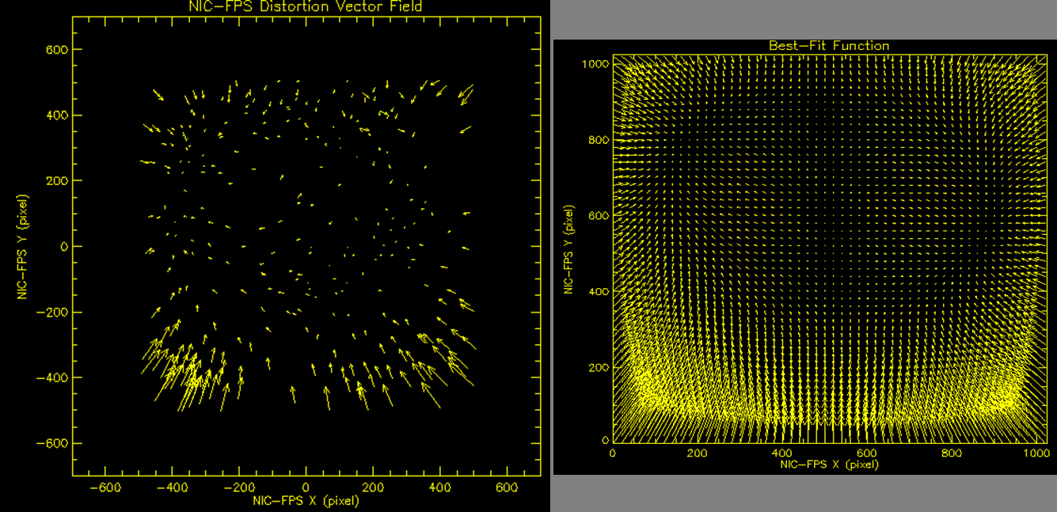
Figure 8. Distortion map of a star field (left) showing the offset vectors from each object’s imaged position to the actual position of the object in the 2MASS point source catalog. Vector lengths are multiplied by a factor of ten to aid the visual representation. The right panel shows the best-fit function offsets of every 20th pixel. Asymmetry between top and bottom is caused by an optics/detector misalignment.

Sky saturation times, the exposure durations before detector reached point of non-linearity on a photometric night, were found to be in excess of 20 seconds for H and Ks filters, 150 seconds for J, and 300 seconds for Z. To avoid non-linearity of objects in the fields, exposure time guidelines were set at 20 seconds for H and Ks, 120 sec for J and Z. These saturation times provided a quick guideline for imaging, but since sky brightness varies considerably from night to night, the proper duration of a set of exposures needed to be re-verified for actual sky conditions and intended targets.

Instrument sensitivity measurements were attempted using a set of NIR standard stars from Persson et al (1998) under photometric sky conditions on November 21st. Observations of three standards were made at low and high airmass to estimate extinction. Data analysis yielded only inconsistent results due to some standards being too bright for the exposure times chosen (non-linearity of detector response), detector noise features, and gain measurement inconsistencies (see Section 2.5). Subsequent observations have yielded preliminary sensitivity and zero point results using sets of 2MASS point sources and relative photometry. Preliminary photometric zero points are 25.0, 25.2, and 25.0 + 0.1 magnitudes in J, H, and Ks respectively, assuming a detector gain of 3.6 electrons per ADU. Instrument sensitivity for a five sigma detection in one hour, using a 5x5 pixel aperture, is estimated to be 22.9, 21.8, and 21.5 magnitudes in the same bands. Since a current detector optimization effort is improving detector system noise characteristics and detector gain will soon be measured in a proven facility, instrument sensitivity measurements will again be attempted after summer maintenance is completed.

Fabry-Perot etalon testing was performed using calibration lamps and extended astronomical sources. Data obtained consistently showed that etalon finesse was much below the design value of 36. This level of performance would be unable to achieve most of the planned scientific results. Troubleshooting on the etalon revealed that the cryogenic instrument was operating in resonance, probably due to short controller time constants. Slowing controller response appeared to eliminate the (audible) resonance, but only improved finesse to the 8-10 range. The spectral range accessible with computer control (without manual controller adjustment) was less than the required value of 1.0 Free Spectral Range(FSR); attempted adjustments were unsuccessful in widening the operating band. The combination of finesse and FSR issues required that the etalon be removed from NIC-FPS for troubleshooting on the bench. After in-house efforts discovered a parallelism problem associated with the y-component and overall plate alignment discrepancies, the system was sent back for vendor (IC Optical, formerly Queensgate) alignment and/or repairs. A detached piezo-electric stack was discovered by the vendor and repaired by bonding with epoxy. Just received feedback from the vendor indicates that the repair did not correct the system fault and that additional investigation will require disassembling and rebuilding the etalon. No decision has yet been made whether to proceed with repairs or procure an alternate system.

2.3 Commissioning Science – December 2004 and January 2005
During the science portion of commissioning, an attempt was made to evaluate instrument performance in a number of realistic science data collection operations. A wide variety of targets was chosen to check performance on extragalactic, galactic, and solar system objects, using both the narrow band and broad band filter sets. No full field spectrometry was attempted because the Fabry-Perot etalon failed to perform as specified during the verification phase.

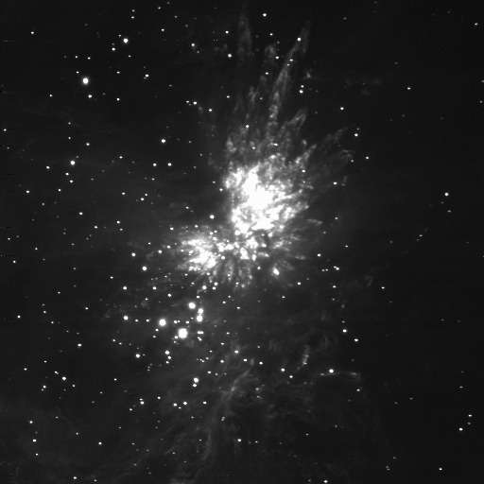
Narrow band imaging proved to be a high quality science capability. Images were taken of several star forming regions, one supernova remnant, and the gas giant planet systems. In Figure 9, the classic Orion Molecular Cloud is imaged in molecular hydrogen (2.12 microns). The bright stars of Trapezium are below and to the left of the tremendous explosion (BN/KL Region) within the molecular cloud; this feature is completely invisible in optical images. The very narrow bandwidth (0.4% of central wavelength) highlights the detail of the shocked giant molecular cloud. Using a second filter, FeII (1.64 microns), the tip of each shocked finger is found in emission. Selecting a third filter, Brackett gamma (2.17 microns), the fingers completely disappear and the ionized region around the Trapezium becomes prominent.

Figure 10 below provides a comparison of Crab Nebula features at 1.64 and 2.12 microns to again highlight the ability of NIC-FPS narrow band imaging to identify dramatically different astrophysical features.
Figure 9. Orion Molecular Cloud is imaged in molecular hydrogen at 2.12 microns. The bright explosion region (BN/KL Region) is not visible in optical images.

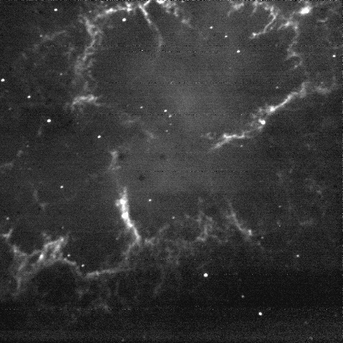
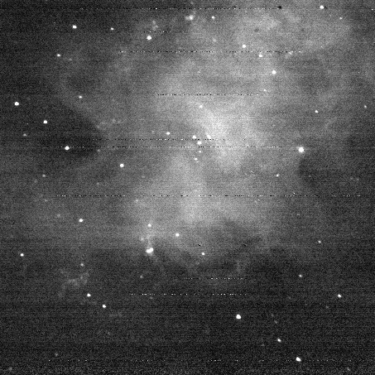

Figure 10. Crab Nebula imaged in FeII at 1.64 microns and molecular hydrogen at 2.12 microns. The contrast between features imaged by two narrow band filters is striking.
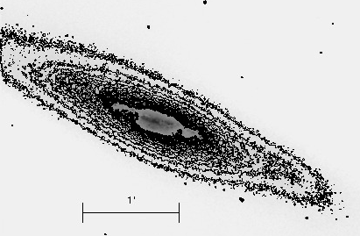
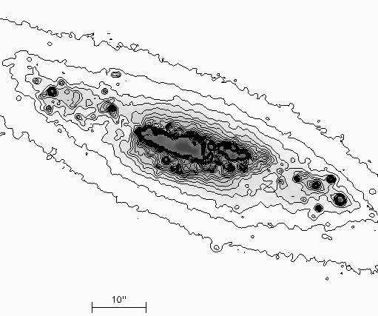
In addition to the 12 narrow band filters described in Paper 2, NIC-FPS is supplied with a set of four broad band filters, Z, J, H, and Ks (last three listed are Mauna Kea filter set). Near infrared road band imaging capability was demonstrated on a series of targets. Figure 11 (top) shows a contour diagram of nearby irregular galaxy M82 in Ks filter. The irregular morphology seen in optical images of this star forming galaxy is not at all apparent as only regular disk structure is revealed in the infrared. An examination of the inner regions of M82 (bottom) show that star formation is concentrated in a dozen or so super star formation regions. The dust penetrating power of infrared observation, combined with the imaging sensitivity and optical quality of NIC-FPS, is apparent in the structural detail of this image which was created by adding 50 seconds of exposures. Additional unplanned broadband imaging was conducted on a pair of gamma ray bursts which triggered during the commissioning science period.

Overall, science data was collected on over one hundred science targets, supporting the investigations of a number of ARC scientists as well as contributing data to the doctoral theses of four or five graduate students at the University of Colorado. Publications are beginning to be issued based in part on these observations
Figure 11. A very regular disk structure is revealed in a galaxy classified as an irregular, star forming galaxy (M82) in the above panel. A group of super star formation regions (below) account for of much of the galaxy’s activity. This image is 50 seconds of integration in Ks.

2.4 Science Operations – January 2005 to July 2005
At the end of the scheduled commissioning period, a decision was made to deploy the instrument for a two month period of shared risk observing in the ARC community, even though there were several maintenance and optimization activities already identified. Community observers prepared alternate plans for observing with other existing ARC instruments in case there arose performance-limiting issues with NIC-FPS. Due to acceptable instrument performance, this trial period was extended until the 3.5 M telescope’s summer maintenance shutdown. The former NIR instrument, GRIM II, was also retired during this period. Over the last several months of shared risk operation, NIC-FPS has been scheduled for approximately 20% of ARC 3.5M observing time. Notable success has been achieved in collecting science data related to gamma ray bursts, high redshift QSOs, dusty active galaxies, Milky Way star formation regions, and solar system objects.

2.5 Detector Noise and Features
As with any new detector system, a number of imaging peculiarities or “features” have been identified. Figure 12 below shows several of these characteristics. The upper left panel is a raw dark image that shows at least three features.

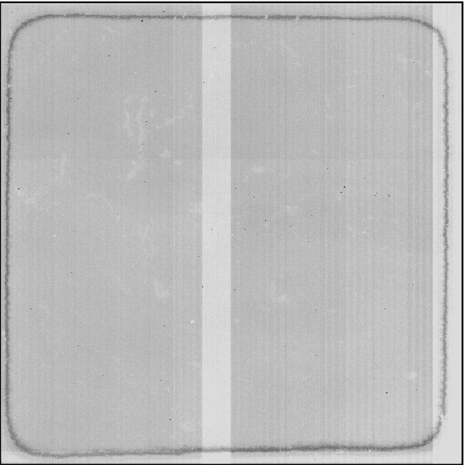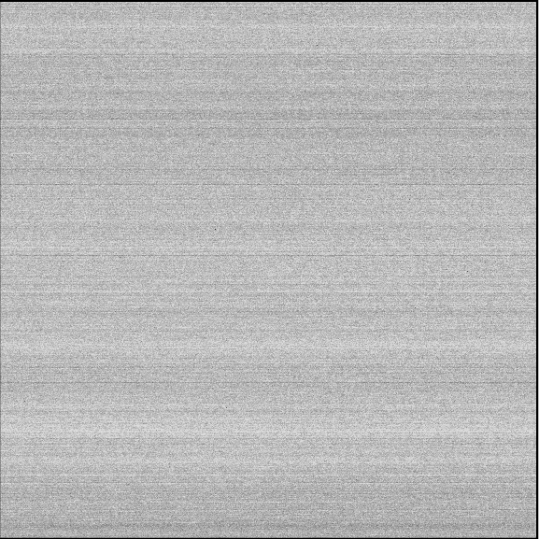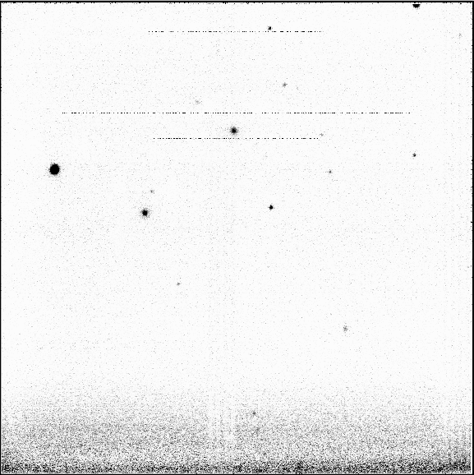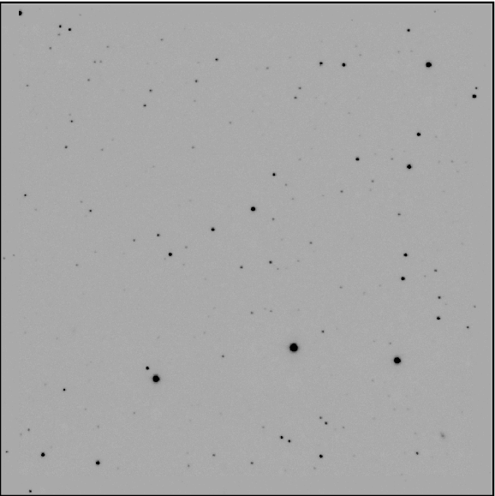
Figure 12. Various detector system “features” are revealed in this set of panels. From upper left, raw dark image with several features, horizontal striping from difference of two identical images, intermittent horizontal spikes and vignetting, and a clean processed image with features removed. See text for details.

Among the prominent features is a circumferential ring that is believed to be a result of the manufacturing process. Also seen are irregular textures, vertical striping, and a slight horizontal division in the uniformity of the exposure level. Each of these features is found to be completely removable during routine processing that includes dark subtraction and flat fielding. Not so easily removed are the two light colored vertical bars that reveal their substantially different bias levels compared to the rest of the field. Careful processing can usually remove most of these structures, but inconsistent photometry is experienced when the removal is incomplete. A new controller timing scheme and/or optimized controller settings (to be implemented this summer) appears to remove these features. The top right panel shows horizontal striping that is most easily seen when two identical images are subtracted. This non-Gaussian noise pattern occurs at the tens of counts level and constitutes the most significant source of detector system noise. On very short or narrow band exposures, this noise source substantially contributes to sky noise or is even the limiting noise source. Data reduction routines have been developed that implement a line-by-line adjustment to eliminate most of the noise contribution of this source. The bottom left panel is stretched to reveal intermittent horizontal spikes (three shown). The source of these spikes has not yet been identified. Employing simple cosmic ray removal software or using the median value of a stack of images removes these spikes. Also seen on this panel is a region at the bottom of the detector that is vignetted. A light baffle, added just prior to commissioning, revealed that the FPA active region was misaligned with the camera optics and/or housing. Realigning the FPA to remove the vignetting is planned for the summer maintenance period. The bottom right panel shows a processed image in which the above features have been successfully removed.

Considerable detector system optimization has been completed and will be implemented during the summer maintenance period. No attempt was made to implement changes as they were developed due to the ongoing shared-risk operations. A period of testing on the sky is planned for late August and September to document detector system characteristics and verify success of the optimization effort.

3. Remaining Work

3.1 Summer Maintenance Shutdown – July 14, 2005 to August 28, 2005
As mentioned previously, a five week period of maintenance is planned for July and August 2005. Major work planned includes detector characterization and optimization, filter wheel rework to improve reliability, vacuum system modification to include an ion pump, adding a low resolution grism and warm slit mechanism, and miscellaneous minor mechanical modifications additions to complete the front housing section. Reinstallation of the Fabry-Perot etalon was also planned but will not occur due to ongoing difficulties with etalon function. All work is being performed at the University of Colorado Astrophysics Research Lab in Boulder. Instrument testing on the sky is scheduled to begin August 27, 2005 and should be complete in September 2005. In addition to the physical system work, a significant effort will be made to complete system documentation which includes Maintenance and Operation Manuals, software documentation, parts lists, and science data reduction tools. The instrument will not be available for two weeks of observatory science operations as a result of this maintenance effort.

3.2 Instrument Turnover to Observatory
At the successful completion of summer maintenance and testing, turn over of the instrument to the observatory (less the Fabry-Perot system capability) will begin. As a facility instrument, NIC-FPS will be scheduled for science operations on a quarterly basis by a set of consortium observers. Science capability will be substantially improved when the Fabry-Perot etalon is incorporated as originally designed. In addition to the short term addition of a grism and warm slit assembly, an upgrade for low and moderate resolution spectroscopy across the full NIR band width is being evaluated. . Ongoing NIR science programs will continue to depend on this new instrument and new programs are expected as the performance and capability of NIC-FPS is enhanced.

4. CONCLUSIONS

The near-infrared imaging capabilities of NIC-FPS have been added to the Astrophysics Research Consortium’s instrument set for the 3.5 meter telescope at Apache Point Observatory. Commissioning and first months of operation have shown the considerable capability of the first deployed low-noise Rockwell Hawaii-1RG (1024 x 1024 pixel) detector for science operations. The planned Fabry-Perot etalon system is being repaired or replaced to ensure that the unique capability for full field spectrometry is realized in the near future. Planned instrument improvements over the next 12 months should substantially increase the science yield, adding to the several successful ongoing science efforts.

ACKNOWLEDGEMENTS

We wish to thank Bruce Gillespie and the staff at Apache Point Observatory for their timely and expert support during commissioning. This work was supported in part by NSF grant AST-0243002.

REFERENCES

1. F. Hearty et al, 2004, “Near-Infrared Camera and Fabry-Perot Spectrometer (NIC-FPS),” SPIE, 5492, 1623-1632
2. Hereld et al, 1990, “GRIM – A near infrared GRISM spectrometer and imager,” SPIE, 1235, 43
3. Persson et al, 1998, “A New System of Near Infrared Standard Stars,” AJ, 116, 2475-2488
4. M. Vincent et al, 2003, “Near-infrared camera and Fabry-Perot spectrometer – NIC-FPS,” SPIE, 4841, 367-375

